Appendix G

RS-485 Transceivers

General Description

The MAX481, MAX483, MAX485, MAX487, and MAX1487 are low-power transceivers for RS-485 communication. Each part contains one driver and one receiver. The MAX483 and MAX487 feature reduced slew-rate drivers that minimize EMI and reduce reflections caused by improperly terminated cables, thus allowing error-free data transmission up to 250kbps. The driver slew rates of the MAX481, MAX485, and MAX1487 are not limited, allowing them to transmit up to 2.5Mbps.

These transceivers draw between 120µA and 500µA of supply current when unloaded or fully loaded with disabled drivers. Additionally, the MAX481, MAX483, and MAX487 have a low-current shutdown mode in which they consume only 0.1µA. All parts operate from a single 5V supply. Drivers are short-circuit current limited and are protected against excessive power dissipation by thermal shutdown circuitry that places the driver outputs into a high-impedance state. The receiver input has a fail-safe feature that guarantees a logic-high output if the input is open circuit.

The MAX487 and MAX1487 feature quarter-unit-load receiver input impedance, allowing up to 128 MAX487/ MAX1487 transceivers on the bus.

Features

♦ In µMAX Package: Smallest 8-Pin SO

♦ Slew-Rate Limited for Error-Free Data Transmission (MAX483/487)

♦ 0.1µA Low-Current Shutdown Mode (MAX481/483/487)

♦ Low Quiescent Current: 120µA (MAX483/487) 230µA (MAX1487) 300µA (MAX481/485)

♦ -7V to +12V Common-Mode Input Voltage Range

♦ Three-State Outputs

♦ 30ns Propagation Delays, 5ns Skew (MAX481/485/1487)

♦ Operate from a Single 5V Supply

♦ Allows up to 128 Transceivers on the Bus (MAX487/MAX1487)

♦ Current-Limiting and Thermal Shutdown for Driver Overload Protection

Applications

Low-Power RS-485 Transceivers

Level Translators

Transceivers for EMI-Sensitive Applications

Industrial-Control Local Area Networks

MAX481/MAX483/MAX485/MAX487/MAX1487 Pin Configuration and Typical Operating Circuit

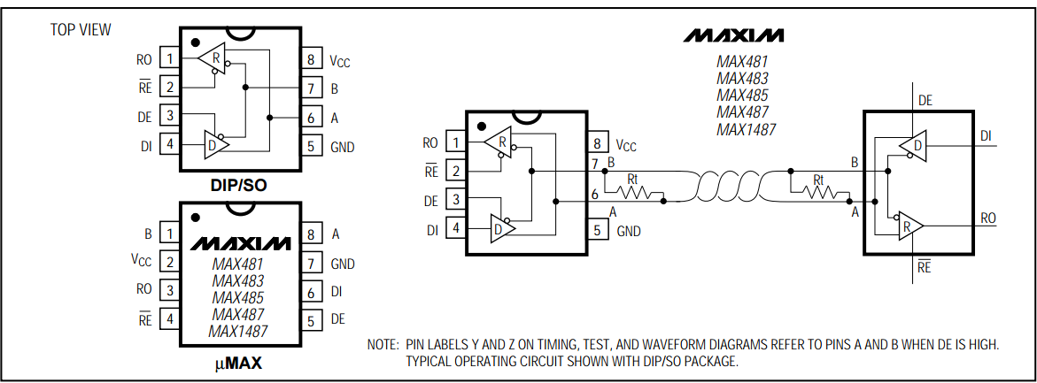

Low-Power Shutdown Mode (MAX481/MAX483/MAX487)

A low-power shutdown mode is initiated by bringing both RE high and DE low. The devices will not shut down unless both the driver and receiver are disabled. In shutdown, the devices typically draw only 0.1µA of supply current.

RE and DE may be driven simultaneously; the parts are guaranteed not to enter shutdown if RE is high and DE is low for less than 50ns. If the inputs are in this state for at least 600ns, the parts are guaranteed to enter shutdown.

For the MAX481, MAX483, and MAX487, the tZH and tZL enable times assume the part was not in the low power shutdown state (the MAX485/MAX488–MAX491 and MAX1487 cannot be shut down). The tZH(SHDN) and tZL(SHDN) enable times assume the parts were shut down.

It takes the drivers and receivers longer to become enabled from the low-power shutdown state (tZH(SHDN), tZL(SHDN)) than from the operating mode (tZH, tZL). (The parts are in operating mode if RE and DE inputs equal a logical 0,1 or 1,1 or 0, 0.)

Driver Output Protection

Excessive output current and power dissipation caused by faults or by bus contention are prevented by two mechanisms. A fold-back current limit on the output stage provides immediate protection against short circuits over the whole common-mode voltage range. In addition, a thermal shutdown circuit forces the driver outputs into a high-impedance state if the die temperature rises excessively.

Propagation Delay

Many digital encoding schemes depend on the difference between the driver and receiver propagation delay times. The difference in receiver delay times, | tPLH - tPHL |, is typically under 13ns for the MAX481, MAX485, and MAX1487 and is typically less than 100ns for the MAX483 and MAX487. The driver skew times are typically 5ns (10ns max) for the MAX481, MAX485 and MAX1487, and are typically 100ns (800ns max) for the MAX483 and MAX487.

MAX481/MAX483/MAX485/MAX487/MAX1487 Typical Half-Duplex RS-485 Network

